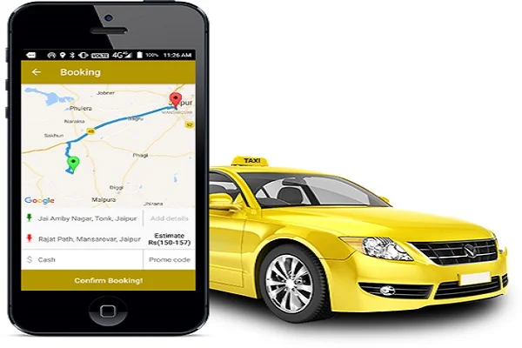
Cab Booking System with SQL

This presentation outlines a robust, data-driven solution for a growing urban sector. We will explore the importance of automation and how SQL powers a seamless, efficient cab booking experience, from real-time assignments to insightful analytics.

Problem Statement:
Addressing Inefficiencies in Traditional Cab Booking Systems


Lack of Centralized Data Access
Customer, driver, cab, and booking records are often stored separately, making it difficult to track rides, manage operations, and maintain historical data.


Manual Booking Systems Are Inefficient
Bookings handled through phone calls or manual entries lead to delays, data inconsistency, duplication, and higher chances of human error.


No Real-Time Analytics or Reporting
Organizations lack real-time insights into booking trends, active trips, idle cabs, cancellations, and driver performance, resulting in poor decision-making.

Objective:
Track Trip Lifecycle from Booking to Completion
Perform Behavioural & Revenue Analytics

- Identify patterns such as frequent cancellations, top-performing drivers, and high-demand booking periods.

- Analyze revenue trends through trip fares, customer spending, and driver earnings.

- Monitor the complete workflow: customer booking → driver assignment → trip execution → fare generation → feedback collection.

- Maintain accurate time-stamped logs for bookings, trip start/end times, distances, fares, and customer interactions.

Enable Feedback and Quality Monitoring

Support Operational Decision-Making

- Assist management in optimizing cab availability, driver allocation, and trip distribution based on real data.

- Enable data-driven reward/penalty decisions for drivers and customers based on performance indicators.

- Capture customer ratings and feedback for every trip to evaluate service satisfaction.

- Analyze driver performance using average ratings and identify low-rated drivers for corrective action.

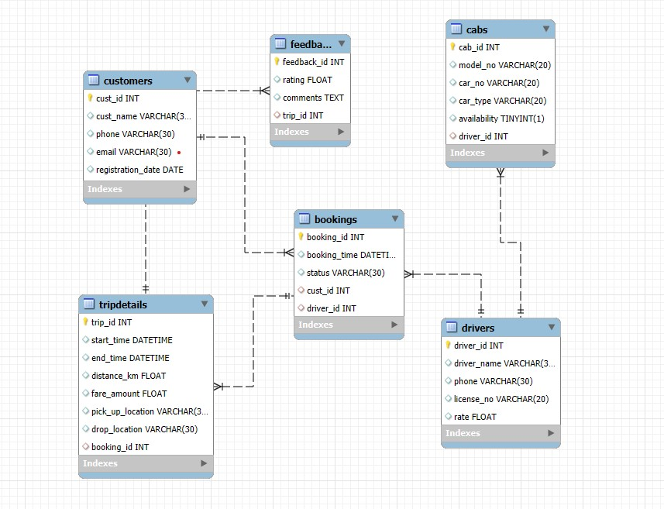
Entity-Relationship (ER) Diagram

A visual layout of our database design.

• One-to-many relationships: One customer can make many bookings, and one driver can complete many rides.

• Key tables include: Customers, Drivers, Cabs, and Bookings.

• Primary and foreign keys are explicitly defined for clarity

Retrieve Cab Details That Are Currently Available

Objective:
Identify all cabs that are currently marked as available for rides.

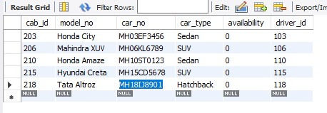

SELECT *
FROM cabs
WHERE availability = 'True';

Insight:
Shows the active fleet available for immediate allocation — useful for operational readiness.

Customers With Most Completed Bookings.

Objective:
Identify loyal or highly active customers.
SELECT cust_name, COUNT(*) AS Completed_Bookings
FROM customers, bookings
WHERE customers.cust_id = bookings.cust_id
AND bookings.status = 'Completed'
GROUP BY customers.cust_name
ORDER BY Completed_Bookings;
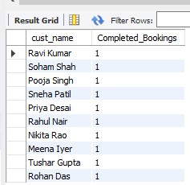

Insight:
Shows top engaged users—ideal for loyalty programs or personalized discounts.

Customer Who Completed the Maximum Number of Bookings

Objective:
To identify the customer with the highest booking completion count.
This helps in determining the most loyal or frequent user.
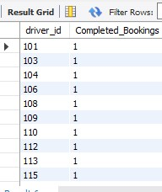

SELECT driver_id, COUNT(*) AS Completed_Bookings
FROM bookings
WHERE status = 'Completed'
GROUP BY driver_id
ORDER BY Completed_Bookings DESC;

Insight:
Shows the top-performing customer based on completed rides—important for loyalty program offerings.

Driver Who Completed the Maximum Bookings

Objective:
To find the driver with the highest number of completed bookings.
Useful for driver performance evaluation and incentive planning.

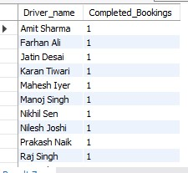
SELECT driver_name, COUNT(*) AS Completed_Bookings
FROM bookings, drivers
WHERE bookings.driver_id = drivers.driver_id
AND status = 'Completed'
GROUP BY driver_name
ORDER BY Completed_Bookings DESC;

Insight:
Identifies star drivers who complete the most trips, contributing greatly to business revenue.

Top 6 Customers by Completed Bookings

Objective:
To identify the three most engaged customers based on completed rides.
Useful for retention and targeted promotional offers.
select cust_name,status,count(*) as Completed_Bookings
from bookings,customers
where bookings.cust_id = customers.cust_id and
status = 'Completed'
group by cust_name
limit 6
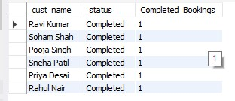

Insight:
Highlights premium customers who frequently use the service.

Cab Model with Highest Total Fare Generated

Objective:
To find which cab model contributes most to total revenue.
This helps in evaluating vehicle performance and future purchasing decisions.

SELECT model_No, MAX(tripdetails.fare_amount) AS Fare_Amount
FROM cabs, tripdetails, bookings
WHERE bookings.booking_id = tripdetails.booking_id
AND bookings.driver_id = cabs.driver_id
GROUP BY cabs.model_no
ORDER BY Fare_Amount DESC
LIMIT 6;

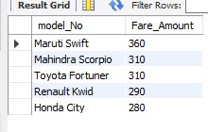

Insight:
Shows the best-performing cab model in terms of revenue generation.

Customer Who Spent the Most Money

Objective:
To find the highest-paying customer based on completed ride fares.
Useful for strategic marketing and loyalty rewards.
SELECT cust_name, status, SUM(tripdetails.fare_amount) AS Total_SpentAmt
FROM bookings, customers, tripdetails
WHERE bookings.cust_id = customers.cust_id
AND bookings.booking_id = tripdetails.booking_id
AND bookings.status = 'Completed'
GROUP BY cust_name
ORDER BY Total_SpentAmt DESC;

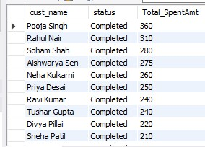

Insight:
Shows the biggest contributor to revenue among all customers.

Revenue Generated by Each Driver

Objective:
To calculate earnings per driver from completed trips.
Supports performance analysis and incentive systems.

SELECT driver_name, SUM(tripdetails.fare_amount) AS Total_Revenue
FROM bookings, drivers, tripdetails
WHERE bookings.driver_id = drivers.driver_id
AND bookings.booking_id = tripdetails.booking_id
GROUP BY driver_name
ORDER BY Total_Revenue DESC
LIMIT 5;

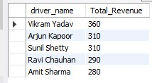

Insight:
Identifies the highest revenue-generating driver.

Conclusion:
This Cab Booking Analysis project demonstrated the complete end-to-end workflow of building a real-world analytical database system — from designing structured tables to generating meaningful SQL insights. The project successfully transformed raw operational data into actionable intelligence for decision-making.

Meaningful Business Insights
Extracted key insights from customer behaviour, driver performance, cab utilization, trip trends, and revenue distribution using SQL queries.

Real-Time Booking Logic Representation
Simulated real-world cab booking operations using well-structured tables for customers, drivers, cabs, bookings, trip details, and feedback.
This logical model supports automated driver assignment, trip tracking, fare calculation, and customer experience assessment.

Creation of Analytical SQL Queries
Developed a wide range of SQL queries — from basic retrieval to advanced nested subqueries — that mirror actual business challenges such as identifying top customers, most revenue-generating drivers, cancellation patterns, and peak demand trips.

Strong Foundation for Further Expansion
The project establishes a scalable database structure that can be extended with features such as dynamic pricing, ride-sharing logic, demand prediction, or real-time dashboards.


Thank You!

We appreciate your time and attention and hope this presentation provided valuable insights into our automated cab booking system.

